Security Engineer

Security Engineer Intro

**Task 1:**

No answer needed

**Task 2:**

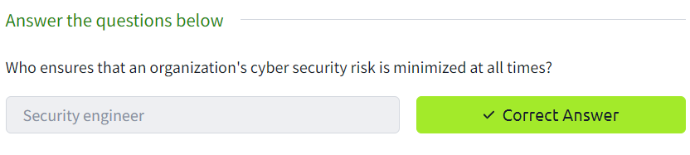

**Task 3:**

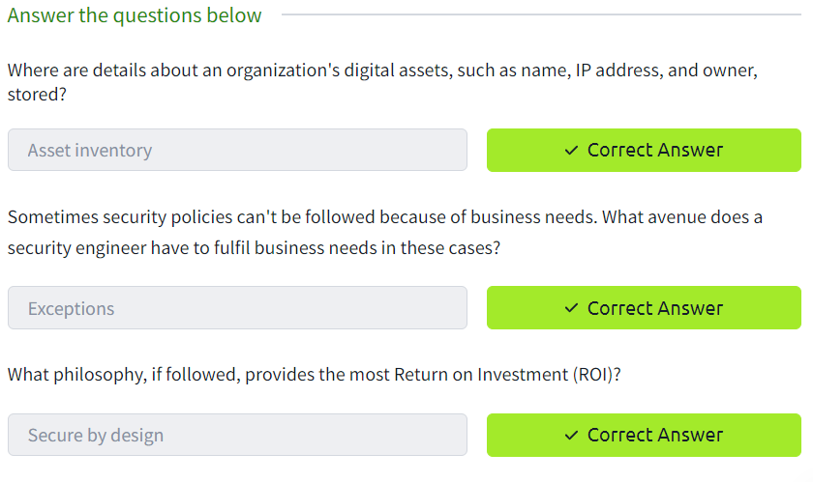

**Task 4:**

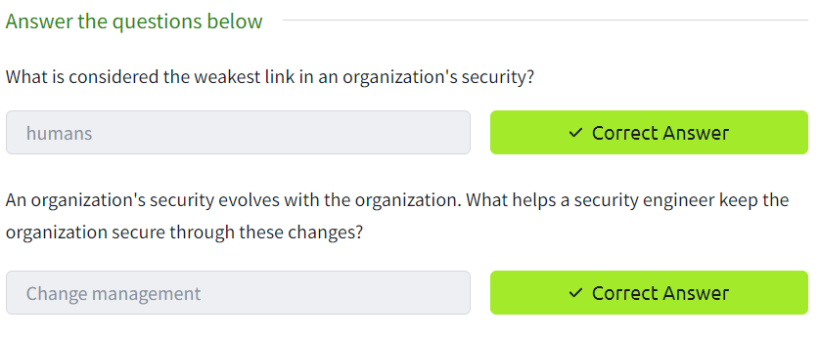

**Task 5:**

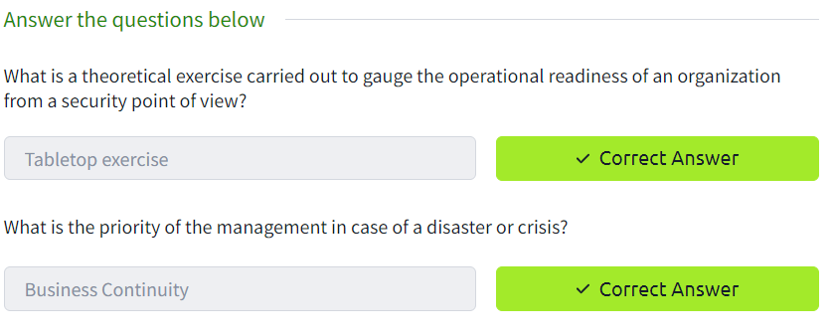

**Task 6:**



